Electronic Supplementary Information (ESI) for
Revised Manuscript: Org. Biomol. Chem. (Article B306613B)

Fig. S1 Behaviors of TF14013, TF14016 and TF14013-Me in mouse serum. HPLC peak areas (%) of the starting materials were shown with the passage of time (hours). All data are the mean values for at least two experiments.

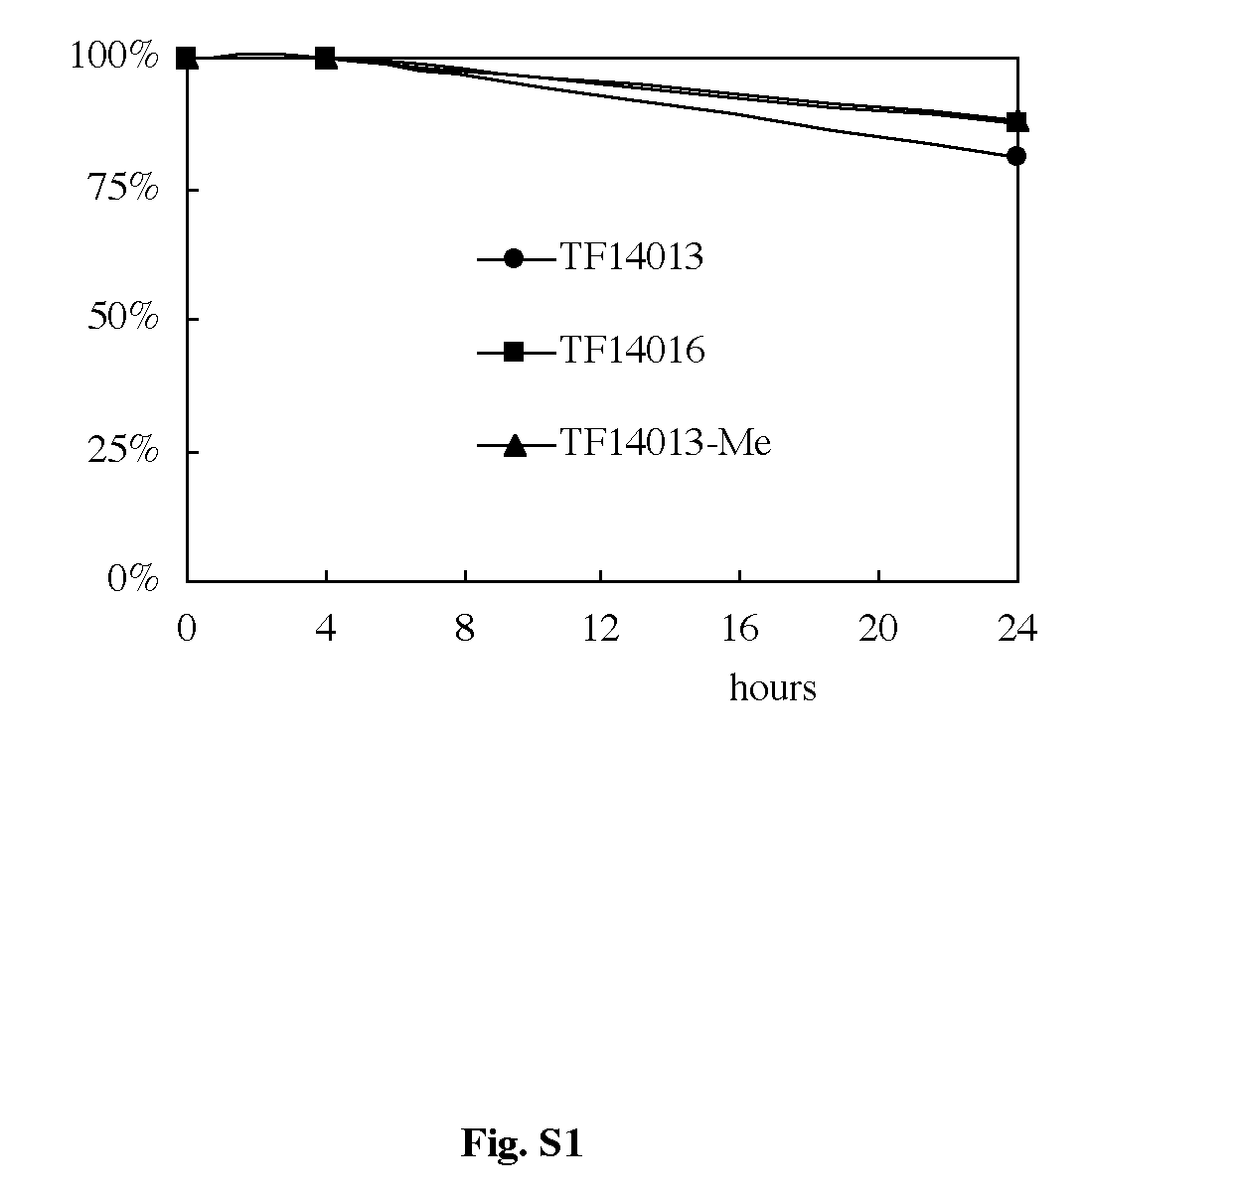

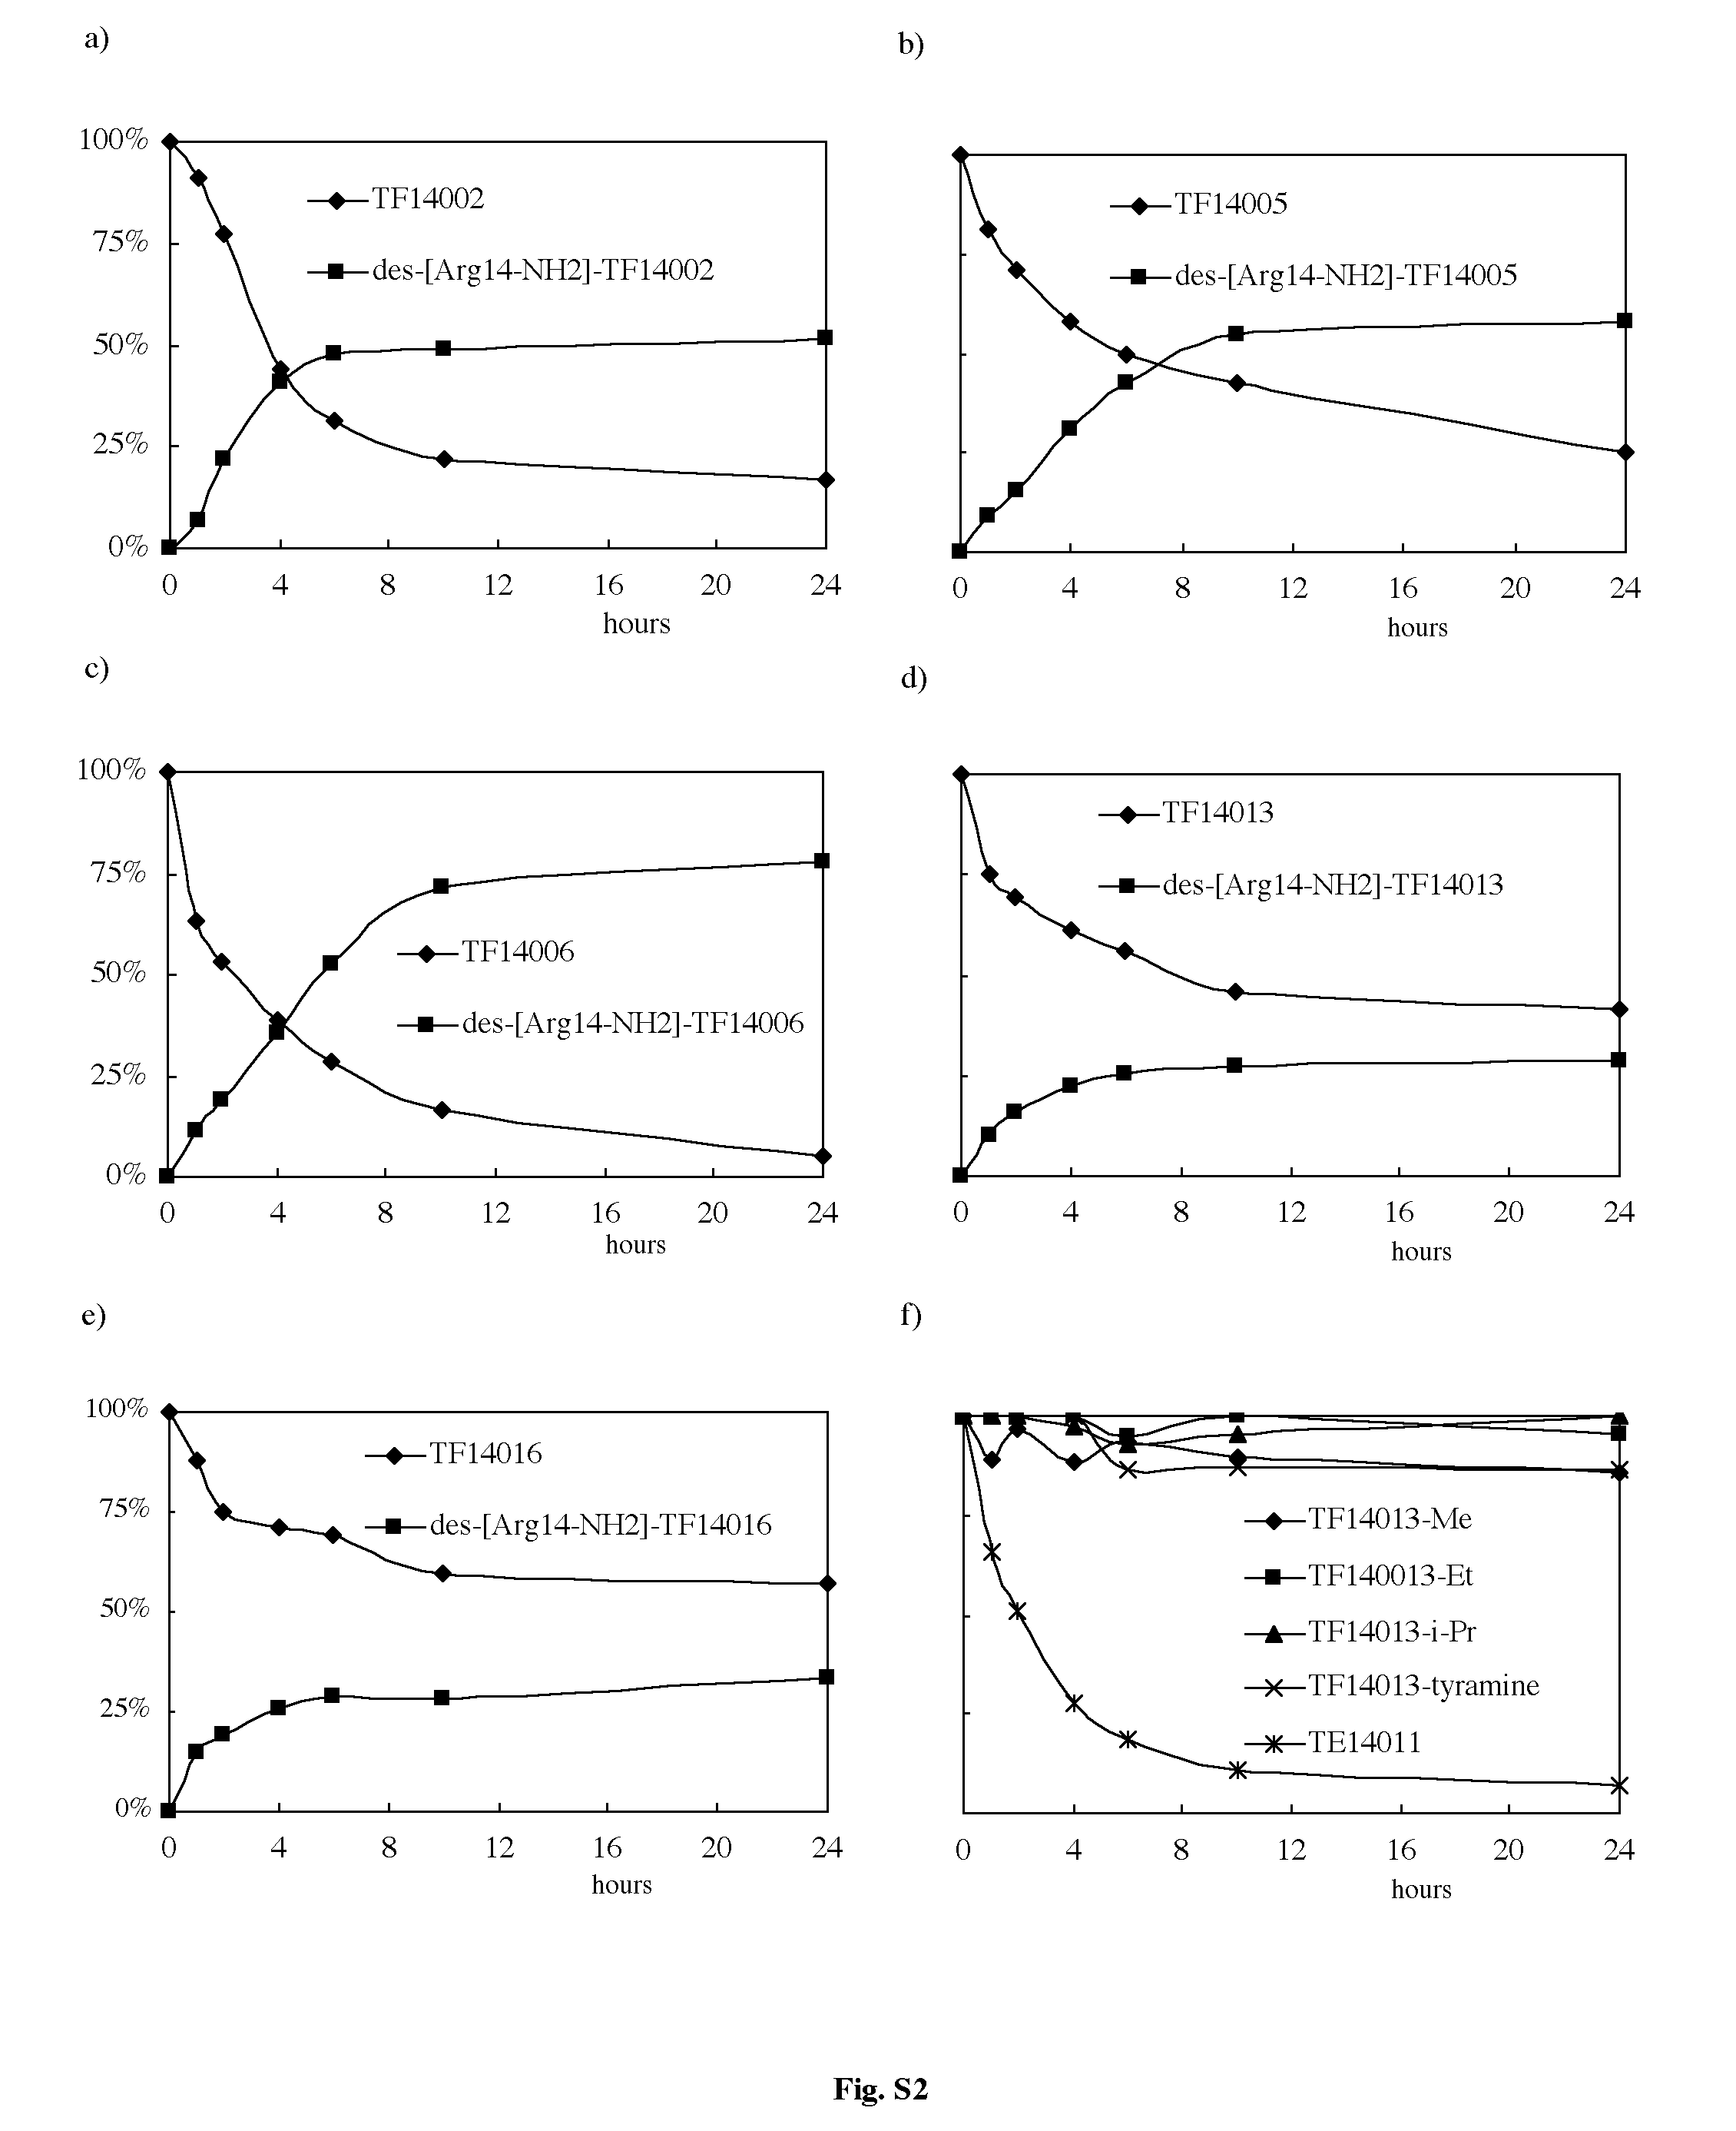
Fig. S2 Behaviors of TF14002 (a), TF14005 (b), TF14006 (c), TF14013 (d), TF14016 (e) and TF14013 analogs (f) in rat liver homogenate. (a—e) HPLC peak areas (%) of the starting material and the degraded product (des-[Arg14-NH2]-parent peptide) were shown with the passage of time (hours). (f) HPLC peak areas of the starting materials (TF14013-Me, TF14013-Et, TF14013-Pri, TF14013-tyramine and TE14011) were shown with the passage of time. All data are the mean values for at least two experiments.

